PACE Technical Documentation for Providers
Version: | 2
Date: | September 2023
The contents of this document are OFFICIAL.
PACE Technical Documentation for Providers 1
1. How to use this document 4
1.1 Summary of updates to this document 4
2. Key Concepts 5
2.1 Introduction 5
2.2 Participant Plan conceptual model 5
2.3 Claiming conceptual model 6
2.4 Relationships and roles 6
3. Participant Plan 7
3.1 Introduction 7
3.2 Definitions 7
3.3 Key concepts 8
4. Plan Supports 10
4.1 Introduction 10
4.2 Definitions 10
5. Plan Budget 11
5.1 Introduction 11
5.2 Definitions 11
5.3 Key Concepts 13
6. Support Catalogue 15
6.1 Introduction 15
6.2 Definitions 15
7. Payment Request 18
7.1 Introduction 18
7.2 Definitions 18
8. Reconciling Payments 19
8.1 Introduction 19
8.2 Definitions 19
9. NDIA APIs 20
9.1 Plan API v4.0 20
9.2 Budget API v4.0 20
9.3 Payments API v4.0 20
9.4 Determine Participant Plan v4.0 20
9.5 NDIS Products v3.0 20

How to use this document
This document provides readers with a technical understanding of key concepts underpinning the interactions between providers and the NDIA, and providers and participants.

The document will assist providers to understand how they will interact with PACE—the NDIA’s new computer system—as the NDIA transitions away from the existing SAP CRM system.

This document describes key fields, the relationship between fields and notes changes in PACE related to those fields.
The NDIS journey maps, which are still in development, will also help explain the business processes and interactions that use the technical concepts described in this document.

This document does not replace the information provided by the Digital Partnership Office that details the technical specifications for APIs. For more information about the use of APIs please email api.support@ndis.gov.au

This document does not replace the technical information on the NDIS website that supports the use of the NDIS Provider Portal. Information to support portal use is available from A new provider portal and tools | NDIS.

This document does not replace technical information related to the NDIS Support Catalogue. Information on the support catalogue is available from Pricing arrangements | NDIS.

Feedback about this document can be provided to NDIS.3P.EVALUATION@ndis.gov.au

Summary of updates to this document
Version | Date of publishing | Changes from previous version
2 | 25 September 2023 | Second release

Key Concepts

Introduction
This section contains visual representations of the relationship between participant plans, participants, providers and payments.
These representations are summaries of the information described in the rest of this document.

Participant Plan conceptual model
The Participant Plan conceptual model shows the relationship between a participant, their plans and the supports in that plan.
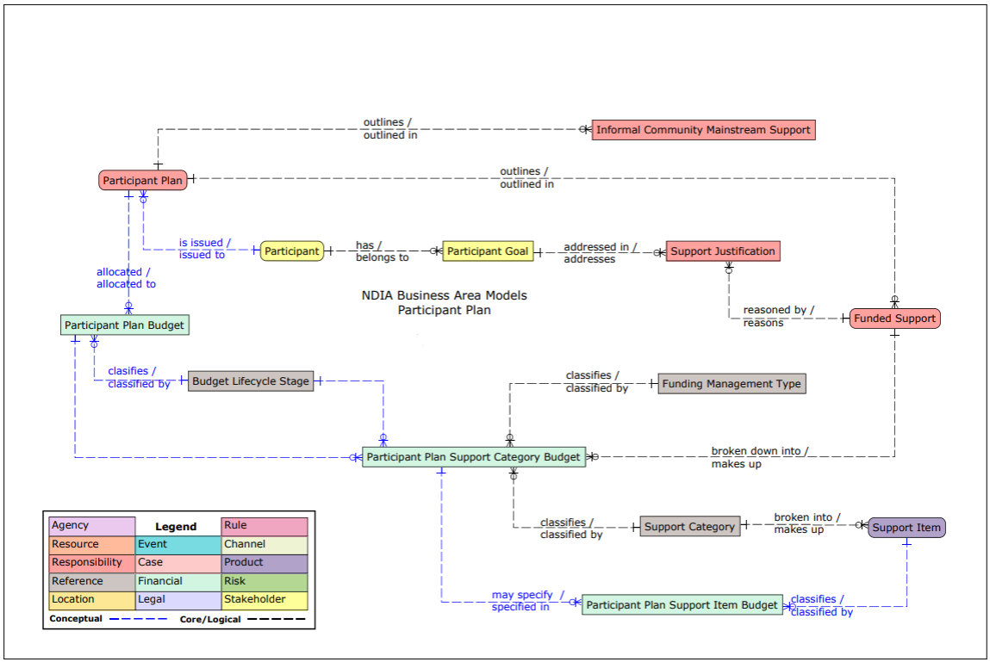

Claiming conceptual model
The claiming conceptual model shows the relationship between a claim, the provider and support catalogue, and source budget.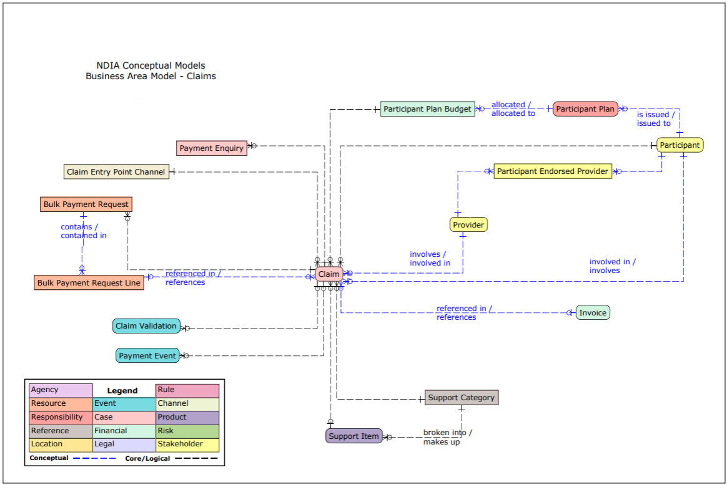

Relationships and roles
All relationships in PACE are at the person-to-person/organisation level. This means they apply to all downstream objects and processes, where relevant. This also means they endure beyond an object, if that object is timebound.

A relationship between parties is assigned a role that describes the nature of that relationship and the period of time the role will be in place.

For example, if a participant nominates a provider as a ‘My Provider’ (formerly known as a ‘Participant Endorsed Provider’ duing the Tasmania Test), then:
- A relationship linkage between a participant and an organisation will be created.
- The relationship will be defined as ‘My Provider’.
- The relationship will be given a start and end review date, and will be active during this period.
- Active plans within the relationship will inherit the ‘My Provider’ relationship without any further action required.

Participant Plan

Introduction
Subject to the participant’s consent, providers can view a participant’s plan via the new NDIS Provider Portal and/or APIs.
PACE has not introduced changes to the participant plan. However, there have been changes to the plan budget.
The participant plan is the overarching structure that contains details about the individualised supports available to a participant, and the outcomes these supports are intended to achieve.
Provider interactions with the participant plan are view only.

Definitions
Field | Definition | Additional Notes
Plan Start Date | The date the plan begins. | A participant’s current plan includes the most recent Plan Start Date.
Plan Reassessment Due Date | The latest date the plan is due for reassessment. | If a plan is superseded by a new plan, the Plan Reassessment Due Date on the old plan will be updated.  PACE has functionality for creating perpetual plans, however this feature is currently inactive—a plan reassessment due date must be entered. Perpetual plans are in effect created through periodically updating the plan reassessment due date.
Participant Statement – About me | Important information about the participant, in their own words.
Participant Statement – My living arrangements | A description of a participant’s living arrangements, in their own words.
Participant Statement – My daily life | A description of a participant’s typical day, in their own words.
Participant Statement – My strengths | A description of a participant’s strengths, in their own words.
My Goals | Short, medium and long-term goals, in a participant’s own words | Plan Supports may or may not be linked to goals.
Plan Supports | Describes the supports a participant will have access to while the plan is active. | Refer to  Plan Supports.

Key concepts
Concept | Definition
Effective period | The period of time between a plan’s start date and plan reassessment due date.  Funding for services will come from the plan that was in effect on the day of the service.
Active plan | Where a plan’s effective period includes today. There can only ever be one active plan.
New versus varied plans | Each plan reassessment results in a new plan being created.  A new plan can be identified because it will have a new Start Date.  Plan variations are amendments to an existing plan.  - A plan variation will not result in changed start or end dates.  - Any variations will apply to the entire plan period, including the period between the plan start date and the variation date.  - A plan variation is not to result in a reduction of plan budget.
Historical plans | A historical plan is any plan where the end date is less than today.  A sequence of plans is determined by chronologically ordering the plan start dates.

Plan Supports

Introduction
A participant’s plan includes supports the participant may access while their plan is in effect.
Subject to the participant’s consent, providers can view a copy of the participant’s plan.
PACE has not introduced changes to plan supports. However, there have been changes to the plan budget.
Providers can only view plan supports if a participant shares a copy of their printed plan. This information is not available through the NDIS Provider Portal or APIs, with the exception of the plan budget (see next section).

Definitions
Field | Definition | Additional Notes
Mainstream Supports | Supports provided through other government services. | These may or may not be linked to goals.
Community Supports | Supports available within the community. | These may or may not be linked to goals.
Informal Supports | Supports provided by a participant’s friends and/or family. | These may or may not be linked to goals.
Plan Budget | A participant’s approved budget in their plan (funded supports). | Refer to Error! Not a valid bookmark self-reference..

Plan Budget

Introduction
Subject to the participant’s consent, providers may be able to see elements of a participant’s plan budget where this information is relevant to their role.
Service providers are not able to see budget information.
Registered plan managers will be able to see budget information for support categories that have been approved to be plan managed.
Support coordinators may be able to see budget information where they have been given express consent.
Changes to the plan budget are:
- Support categories will only have a single funds management approach approved (either self-managed, plan-managed or agency-managed).
- Support category budgets have the option of being cumulatively released in instalments.
  - NOTE: instalment functionality is an inactive feature. There is no change at this stage to the availability of budgets.
- Support category budgets marked as “flexible” will be aggregated into a single flexible budget as per the funds management approach.
Providers can view plan budgets by using the NDIS Provider Portal and/or APIs. Plan budgets are indirectly adjusted, for example by budget drawdown, through the provider claiming process (see
Payment Request).

Definitions
Field | Definition | Additional Notes
Support Start Date | The first date in the plan that a support can be provided. | This field does not appear in the printed plan or the portal. It is a back-of-house data marker that is replicated from the plan start date.
Support End Date | The last date in the plan that a support can be provided. | This field does not appear in the printed plan or the portal. It is a back-of-house data marker that is replicated from the plan end date.
Support type | A grouping of support categories with similar claiming controls applied. | See  Support Catalogue.
Support category | Standard description for a support that may be approved as part of a participant’s plan. | This description includes binding instructions that must be complied with in order to spend in accordance with the plan.
Support description / notes | Additional information and instructions that may be included to help tailor the support being approved to the participant. | If populated, these notes include binding instructions that must be complied with in order to spend in accordance with the plan.
Funds management approach | The funds management approach that has been approved for the management of the support. | The funds management approach may be:  “Self Managed” – a participant will directly manage this support.  “Plan Managed” – the participant will engage a registered plan manager for this support.  “Agency Managed” – the NDIA will manage the support on the participant’s behalf.  “In Kind” – funding will be managed by the NDIA.
Approved/Allocated amount | The total budget allocated to a support category.
Spent amount | The sum of claims to date that have drawn down on the support category budget.
Remaining/Available amount | The amount remaining in a support category’s budget. | The remaining amount calculated by combining all instalment amounts to date, minus the spent amount.  For flexible support categories and individual support categories, the remaining budget may be in deficit.
Instalment period | The frequency that an instalment amount will be added to a support category’s remaining budget. | Inactive feature – all support categories have an instalment period of “once off”.
Instalment amount | The amount added to a support category’s budget with each instalment. | Inactive feature – instalment amount is equal to “approved budget”.

Key Concepts
Concept | Definition
Stated supports | The support catalogue lists the support items that map to a support category. Any item that maps to a support category may be funded from that support category’s approved budget.
Flexible supports | The support catalogue lists support items linked to a support category.  A flexible support item may be funded from the total flexible budget provided the support category is included in the plan (even if that support category does not have any approved budget or budget remaining).  Flexible support categories may have differing funds management approaches. If this is the case, the item can only be funded from the flexible budget that aligns to the support category’s approved fund management approach.
Total flexible budgets | Support categories marked as “flexible” have budgets that are aggregated. That is, the total flexible budget is the sum of the “approved budget” for all flexible support categories.  Flexible support categories may have differing funds management approaches. If this is the case, the total flexible budget for each approach is calculated by combining the relevant category budgets.  Budgets are not flexible between funds management approaches.

Support Catalogue

Introduction
The Support Catalogue is a reference table that documents the rules related to supports the NDIS funds, and how these are funded from participant plans. The structure of the catalogue helpfully groups support items with similar rules and support outcomes into categories and types.
PACE has introduced some changes related to the support item groupings. However, there have been no changes to the overall support catalogue structure.
There is no longer a direct link between a support item number and the category or registration that it maps to—however, this information can still be determined using the support catalogue.
There have been no changes to support items, their numbers or claiming rules.
It should be noted that PACE makes increased use of the support catalogue as a reference table. Unlike the current support catalogue, there is no limit on the number of support types and categories. Future policies that affect how supports are funded from participant plans will be implemented by updating the groupings in the support catalogue.
Providers can download the support catalogue from the NDIS website and/or APIs.

Definitions
Up-to-date information on the support catalogue is available from Pricing arrangements | NDIS.

Field | Definition | Additional Notes
Support Type | The highest level grouping of items. | There are currently four support types:  - “Core” – items in this grouping a flexible.  - “Recurring” – items in this grouping will be paid on a periodic basis.  - “Capital” – equipment and other capital items.  - “Capacity Building” – items in this grouping are intended to support specific outcomes.
Support Category | Grouping of items that may be used to meet the same support need. | New support categories currently include:  - Home and Living, separating SIL, MTA and ILO from Daily Activities.  - SDA, separating SDA from Home Modifications.  - Behavioural Supports, separated from Relationships.  - AT maintenance and rental, separated from Assistive Technology.
Support Item | A claimable support item. Each item has an associated description and number.
Flexible/Stated | Indicates whether the item belongs to a flexible or stated category.
My Provider prerequisite | Indicates whether a provider must be listed as My Provider by a participant prior to funding being available.
Registration group | Indicates the registration required by a provider to claim from agency managed budgets.
Unit | The unit used for measuring the service, for example hours, that must be used on the invoice.
Valid from date | The date the rules related to an item came into effect.
Valid to date | The date the rules related to an item ceased to be in effect.

Payment Request

Introduction
Payment requests are how providers, plan managers and self-managing participants seek payment for services funded in a participant’s plan.
There have been no changes to how bulk payment requests are lodged. Payment requests continue to be lodged through the current MyPlace Provider Portal or using APIs.
It should be noted the MyPlace Provider Portal single claim interface is not available. However, single claims should be lodged using the bulk claim process in the MyPlace Provider Portal.

Definitions
All relevant information for payment requests is available on the NDIS website - Bulk payments | NDIS

Reconciling Payments

Introduction
Providers can access a historical view of the submitted payment requests via the myPlace Provider Portal and APIs for both PACE and SAP plans.
At this stage, only payments for SAP plans are available via downloadable reports. Development is underway for a like-for-like downloadable report for PACE plans. This document will be updated when this change is made.
In addition, development is currently underway to implement claim submissions on the myPlace Provider Portal. This document will be updated when this change is made.

Definitions
Field | Definition | Additional Notes
Submitted Payment Requests | Single Payments submitted via the myPlace Provider Portal or the APIs.
Uploaded Bulk Payment File | Bulk file payment request uploaded via the myPlace Provider Portal or the APIs.
Payment Request Number | Number assigned to submitted payment requests.
Status | Payment statuses displayed. | - Rejected  - Incomplete  - Pending Payment  - Paid  - Cancelled  - Awaiting Approval

NDIA APIs

Plan API v4.0
Retrieves appropriate approved participant plans and goals if consent has been granted by the participant to the registered NDIS provider.

Budget API v4.0
Retrieves participant plan managed budget details if consent has been granted by the participant to the registered NDIS provider.

Payments API v4.0
Submits single or bulk payment requests for supports against a participant’s plan and retrieves a list of all payment requests made by the provider for a specified participant if consent has been granted by the participant to the registered NDIS provider.

Determine Participant Plan v4.0
Retrieves details on whether the participant has an existing or PACE plan if consent has been granted by the participant to the registered NDIS provider.

NDIS Products v3.0
Retrieves details on a Support Item, its unit of measure and validity time frame.

More information on the NDIA APIs and how to connect your systems can be found on the Connecting with NDIA systems page on the NDIS website.

